This is a test of git and github

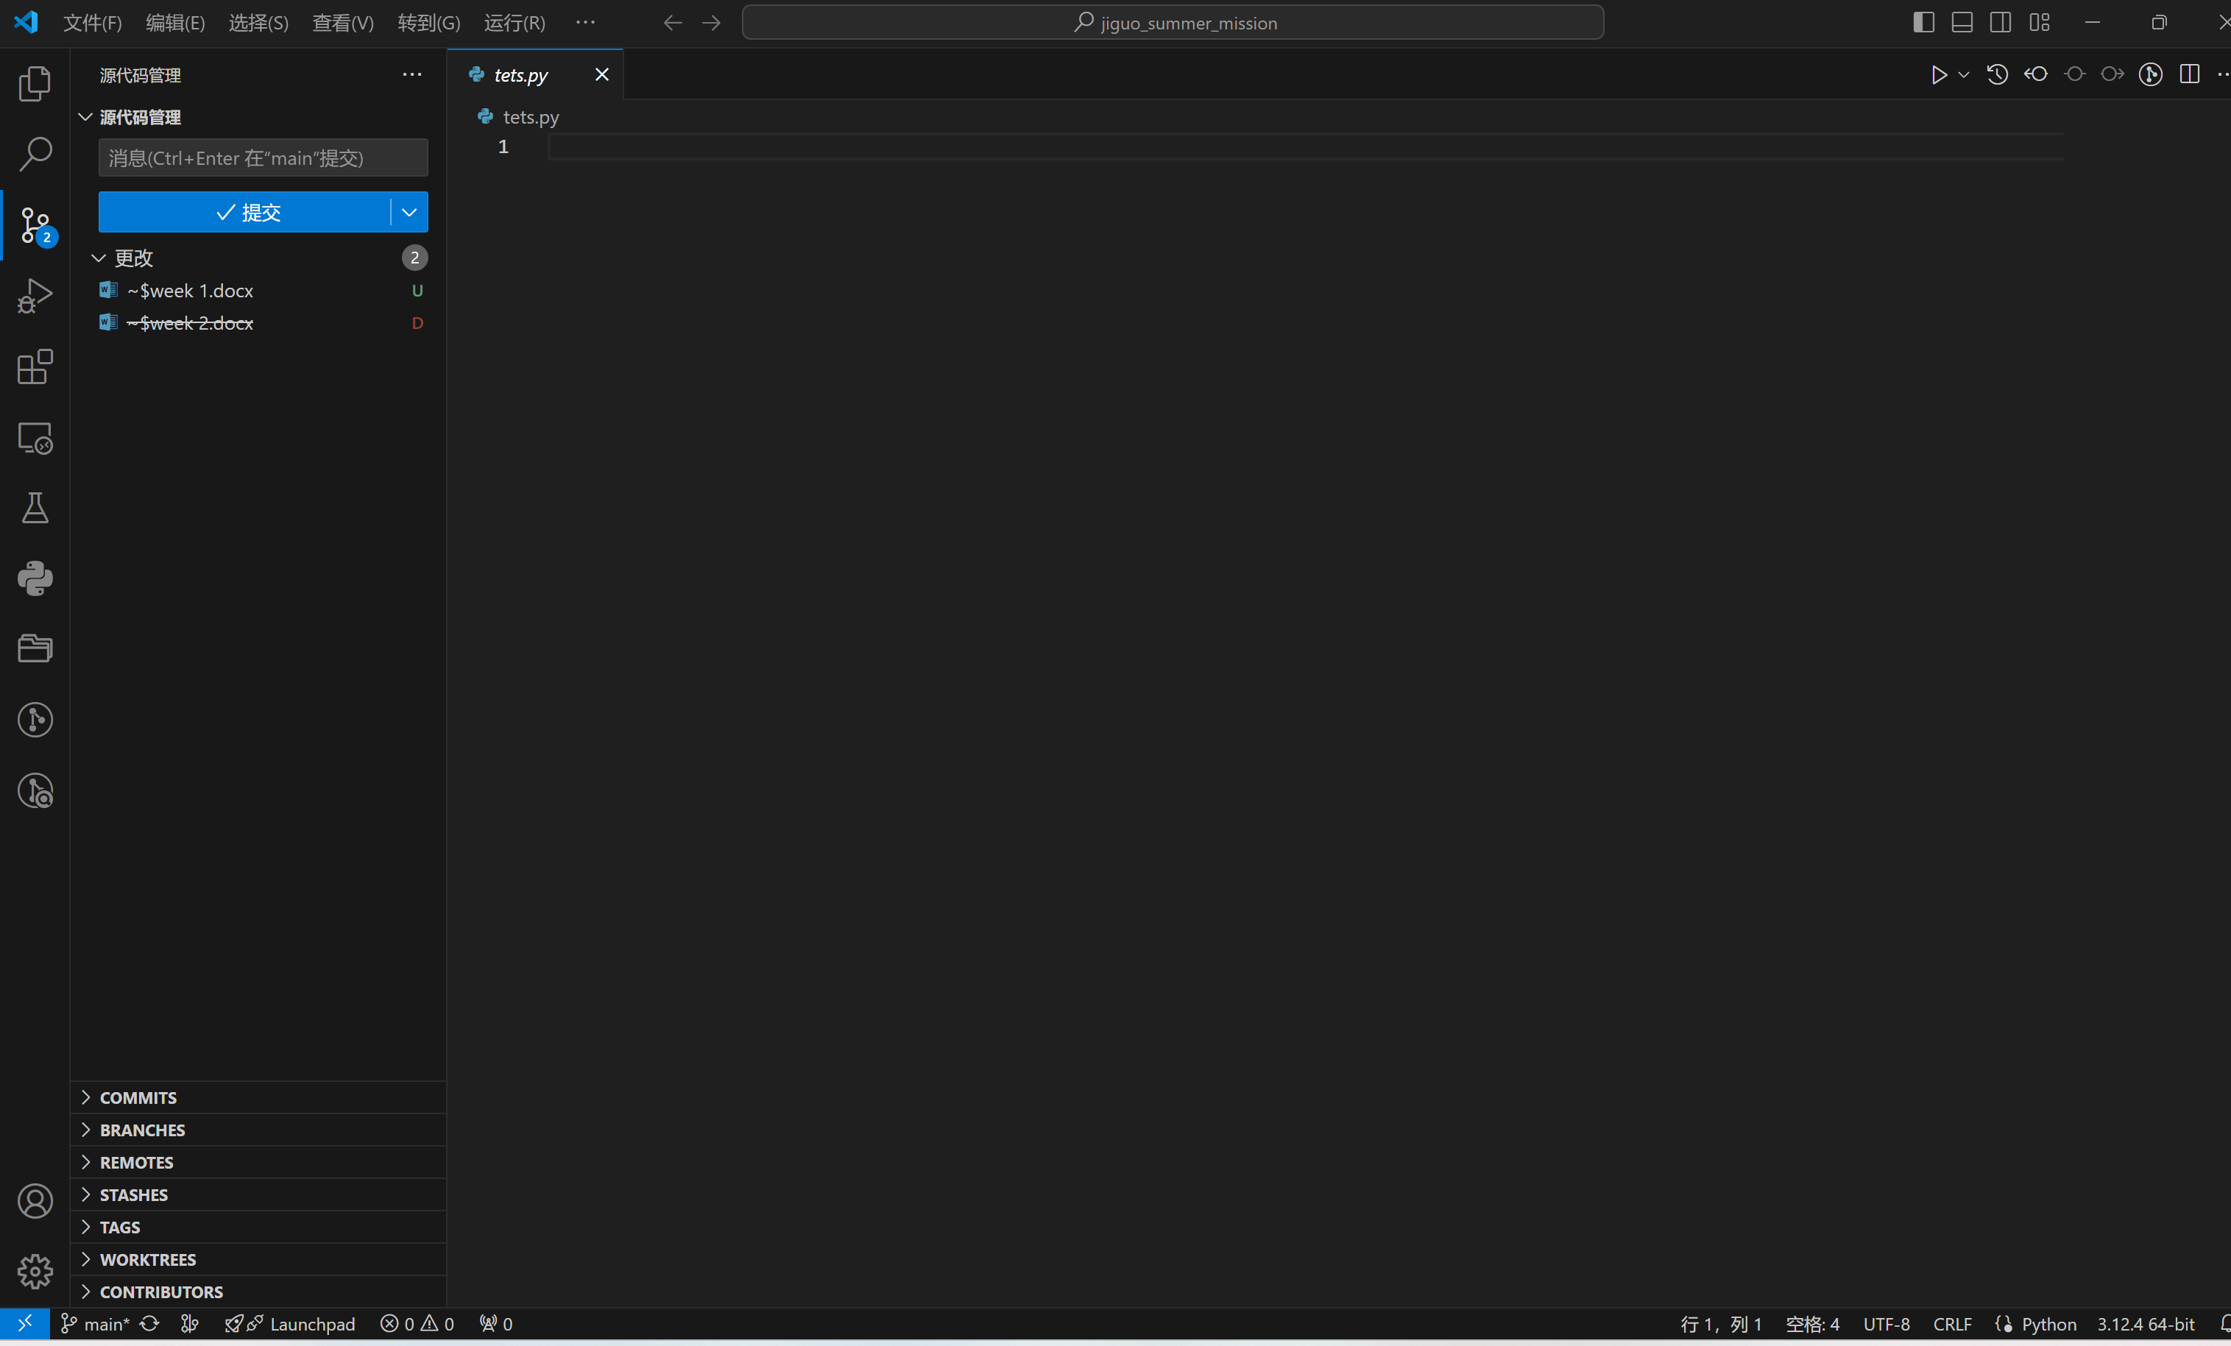

配置git 并注册GitHub